Guild meetings  We usually meet on the third Saturday of each month at Shawford Parish Hall (except August and December). Meetings start at 10am and finish by 4pm.  Annual membership for April 2023 to March 2024 is £20, but there is a reduced rate for new members joining after 1st January 2024 and young people up to 24 years old.  There is an entrance fee of £2 for members, payable on the door.  Visitors are welcome and pay a door fee of £5.  Membership benefits include:  - skillshare, show & tell, talks and an annual fibre event  - sales table  - library and equipment for hire  - weaving days and specialist workshops with priority bookings for members  - email updates on upcoming events  There is also an active facebook group. |  |  | PROGRAMME OF EVENTS 2024
 |  |  | 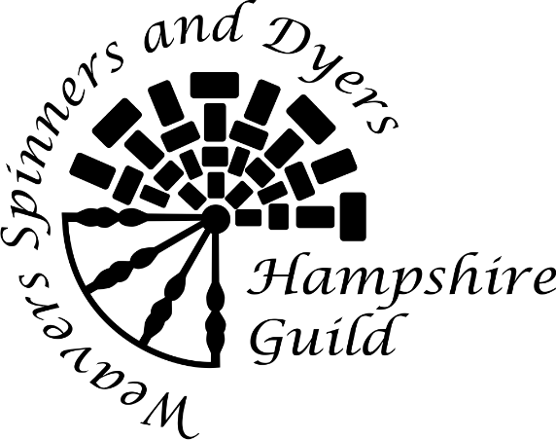
GUILD CHAIR: ADAM BATTING
Email: chairofhantswsd@yahoo.co.uk

SECRETARY: SALLY TOPSOM
Email: secretaryhantswsd@yahoo.co.uk

TREASURER: CORAL NEWTON

Website: www.hantswsd.org
Hampshire Guild of Weavers Spinners and Dyers

Charity number: 1170781

Hampshire Guild Programme 2024  20 Jan Natures Rainbow: natural dye gardening  17 Feb The Border Tart: travels in India – stitching and indigo – VIRTUAL TALK  16 Mar Guild skillshare day  20 Apr The Sussex Spinner: knitting history pre Industrial Revolution and tips on  Spinning wheel maintenance  18 May tbc  15 Jun tbc  20 Jul AGM and Janet Phillips: designing woven fabrics  21 Sep Guild Open Day: free - all welcome  19 Oct Fibre day: the Weavers Loft and Woolastons Woolly Wonders  16 Nov Andy Skinner: medieval Southampton and the wool trade  14 Dec Shared festive lunch and Alec McArdle: the making of a medieval garment  Note that the programme may be subject to change - please check the Guild website or Facebook page |  | Guild Weaving Days  28 Sep, 26 Oct and 23 Nov – details to follow  Youth Activities  The Guild runs a programme of activities in partnership with other organisations, to enable young people to experience fibre related craft. For further information see the Youth Activities page of the Guild website at www.hantswsd.org/youth-guild  the national Association of Weavers Spinners and Dyers  is the umbrella organisation for over 100 Guilds across the UK and beyond. It provides:  - the Journal – its quarterly magazine.  - national conferences, exhibitions and summer schools – held biennially  - recognised qualifications certifying individuals' high level of achievement and competence in their chosen craft.  Further information on the Association is available via its website: www.wsd.org.uk/

