Guild meetings  We usually meet on the third Saturday of each month at Shawford Parish Hall (except August and December). Meetings start at 10am and finish by 4pm.  Annual membership for April 2025 to March 2026 is £20, but there is a reduced rate for new members joining after 1st January and young people up to 24 years old.  There is an entrance fee of £2 for members, payable on the door.  Visitors are welcome and pay a door fee of £5.  Membership benefits include:  - skillshare, show & tell, talks and an annual fibre event  - sales table  - library and equipment for hire  - weaving days and specialist workshops with priority bookings for members  - email updates on upcoming events  - affiliation to the national Association of Guilds of Weavers, Spinners and Dyers  There is also an active facebook group. |  |  | PROGRAMME OF EVENTS 2025
 |  |  | 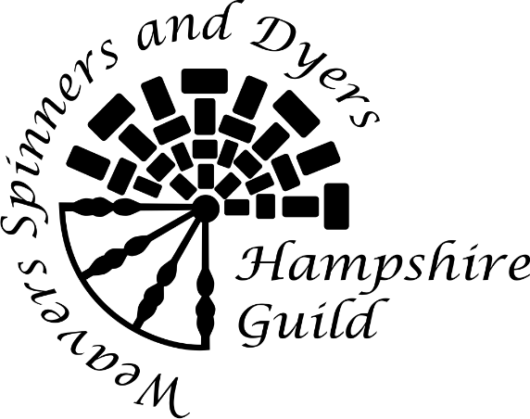
GUILD CHAIR: ADAM BATTING
Email: chairofhantswsd@yahoo.co.uk

SECRETARY: SALLY TOPSOM
Email: secretaryhantswsd@yahoo.co.uk

TREASURER: CORAL NEWTON

Website: www.hantswsd.org
 Hampshire Guild of Weavers Spinners and Dyers

Charity number: 1170781

Hampshire Guild Programme 2025  18 Jan Jenny Lang talks about the Shetland Wool week  15 Feb Carey Fleiner workshop and talk on Sprang  15 Mar Guild skill share day  19 Apr Harriet Riddell – stitched portraits and stories  17 May Joyce Meader history of knitting patterns and film work  21 Jun Jen Best: the wandering thread – wellbeing and craft  19 Jul AGM and speaker tbc  21 Sep Guild Open Day: free - all welcome  18 Oct Fibre day with Tereshina Roberts  15 Nov Jude Gilchrist – from Warminster to Wales - Loomin’ Marvellous  13 Dec Libby Ashdown - Passementerie  Note that the programme may be subject to change - please check the Guild website or Secretary’s monthly roundup email |  | Guild Weaving and Spinning Days  We will have a number of additional Saturdays dedicated to weaving or spinning where Guild members can bring and share their projects and get some hints or tips. Some of these days will feature optional workshops. We also hope to have a summer dyeing day. There will be a modest charge to cover costs.  Winter Weaving days:  25 Jan, 22 Feb, 27 Sep, 25 Oct, 22 Nov  Spring and Summer Spinning days:  21 Mar, 26 Apr, 24 May, 26 Jul  Listen out for details at Guild meetings and in the secretary’s monthly round-up email.  the national Association of Weavers Spinners and Dyers  is the umbrella organisation for over 100 Guilds across the UK and beyond. It provides: a quarterly Journal; national conferences, exhibitions and a biennial summer schools; recognised qualifications. Further information is available via the Association’s website: www.wsd.org.uk/

